**Student Name________________________ Date_________________**

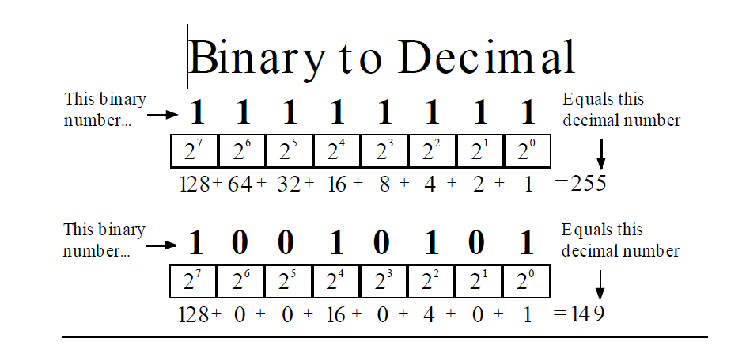

1. 0 1 1 0 1 1 1 0------110
2. 0 0 1 1 1 1 1 0----64
3. 0 0 0 0 1 0 1 0---10
4. 1 0 1 0 0 0 0 0------160
5. 1 0 1 0 0 0 0 1-----161